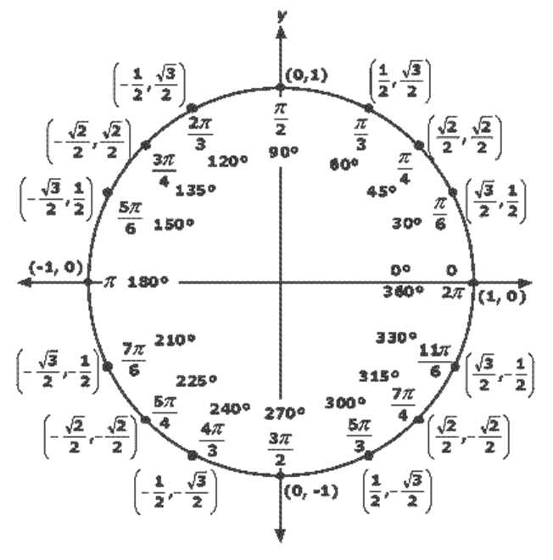
ICM Final Exam Note Sheet NAME__________________________________

